**MIDDLE EAST TECHNICAL UNIVERSITY**

**DEPARTMENT OF ELECTRICAL & ELECTRONICS ENGINEERING**



**TROY TECH**

**WEEKLY REPORT #2**

**21.02.2019-28.02.2019**

**Section :** 7

**Studio Coordinator:** Mustafa Mert ANKARALI

**Partners :**

Hasan ÖZKARA - 2031888

Kağan ÖZASLAN - 2031854

Caner POTUR - 2031250

Mustafa Ercan OKATAN - 2031193

Mert KAYIŞ – 2030997

In this week, we did some experimental things.

* Bought plexiglasses as two different diameters 17cm and 20cm to make a smaller body than our demo one in the first term.
* Bought omniwheels
* Do designing for body of the robot and placement of motors
* Bought solenoid shooter and tried it

We faced with some problems. Our solenoid is not effective one and we are supposed to figure it out by developing or using another one or another approach.

For omniwheels we couldn’t try exactly how they work because the mounting omniwheels on our motors need another connection which we don’t have yet.

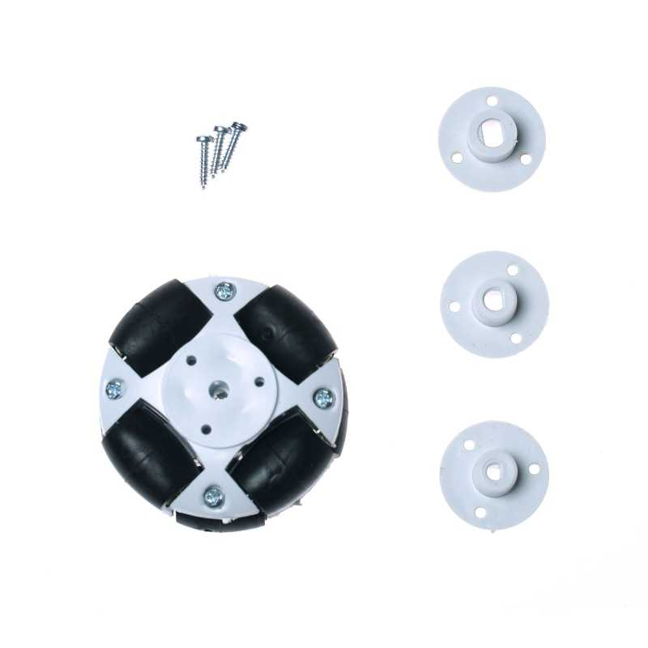

Figure 1: Our omniwheels

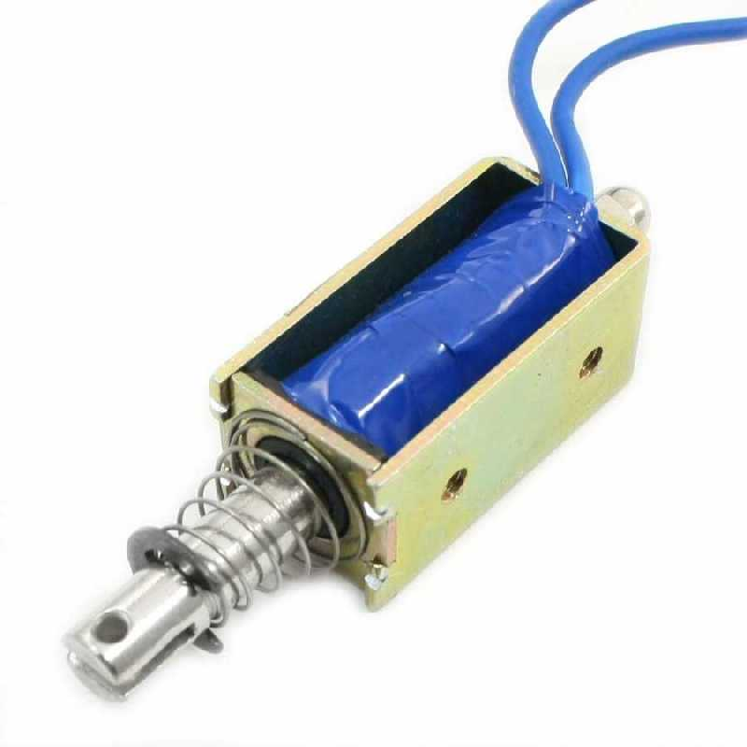

Figure 2: Our shooting solenoid

**Next Week Plan**

We are planning to

* decide whether we will use omniwheel or not by assembling it on our body and trying to operate
* keep trying shooting system and improve it
* decide the last changes for critical design review